Safety Flash Submission Template

IMCA Safety Flashes are intended to summarise key safety matters and incidents, allowing wider dissemination of lessons learnt from them. The information you provide below will be reviewed within the secretariat and an anonymised and sanitised version prepared for your clear acceptance or otherwise.
The effectiveness of the IMCA safety flash system depends on receiving reports from members in order to pass on information and avoid repeat incidents. Please consider adding the IMCA secretariat (incidentreports@imca-int.com) to your internal distribution list for safety alerts and/or manually submitting information on specific incidents you consider may be relevant.
Please indicate which IOGP Life-Saving Rules (if any) were dominant factors in this incident
Bypassing safety controls | Confined spaces | Driving | Energy Isolation | Hot Work | Line of Fire | Safe Mechanical Lifting | Work Authorisation | Working at height | NONE
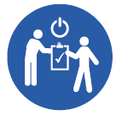 |  | 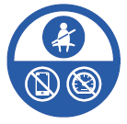 |  |  | 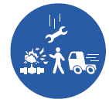 | 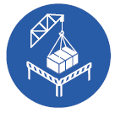 |  | 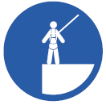
☐ | ☐ | ☐ | ☐ | ☐ | ☐ | ☐ | ☐ | ☐ | ☐
If possible, please include photographs or diagrams with some explanatory text. If you wish, extend the size of these boxes to suit your purposes. Send your finished submission to incidentreports@imca-int.com
Title

A concise focus on the main issue, capturing the essence of the incident, e.g. “fatality during air diving operations”
What happened?

Brief description of what happened. Names, locations and dates can be omitted, though this will be checked carefully by the secretariat. If possible, try to outline the incident in the first sentence, before providing more detail thereafter: e.g. “A crew member was struck by a falling object. The incident occurred when…”. If there were injuries, fatalities or other consequences like equipment damage or lost time, please tell us briefly what they were, and what treatment was required for the injured person(s). Please indicate if the incident was a near miss, an LTI, a restricted work case or a first aid injury.
What went wrong? - Investigation and findings

All incidents should be investigated; all investigations have findings. Information you put in the “What happened” section may be moved to this section, e.g. sea state or weather, or the experience and competence of the crew involved. Typical findings include whether or not safety management tools such as risk assessment, toolbox talks, management of change etc. were properly used, or details of what actually went wrong. A real example is: “the installed winch was not suitable as it had no safety mechanism to prevent free fall when lowering”.
What were the causes of the incident?

Identify the immediate causes, and as far as possible, the root causes, of the incident.
What lessons were learnt?

What were the main lessons learnt from the incident? What lessons could be applicable to the wider IMCA membership and the industry? How do we prevent recurrence of the incident
Actions – what must be done?

What did changes did you make as a result of this incident? What actions, if any, can IMCA members take from this incident?

